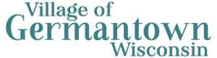

Community Engagement Program

Overview
This Community Engagement Program (CEP) provides the framework for the Village of Germantown to gather input to help guide redevelopment planning in the Village Center District and on three Village owned parcels located in the area. A draft plan was reviewed by the Village Board at their meeting on Monday, February 2, 2026.
Incorporating engagement results into planning activities is a key aspect in gaining community buy-in. This effort will seek to gain general and/or broad feedback regarding development/re-development within the overall Village Center District, with more focused or specific focus on the following three parcels:
Property | Existing Zoning | Future Land Use Map
Flower Source | Neighborhood Business (B-1) & Agricultural (A-2) | Village Center District
Ascension Property | Neighborhood Business (B-1) | Village Center District
Grosenick Property | General Business (B-3) | Village Center District
This CEP provides written procedures that are designed to foster public participation in the village with the following goals in mind:
- Employ both traditional and innovative methods of engagement.
- Collaborate with residents, property owners, business owners and operators, community organizations, and other key stakeholders.
- Utilize both virtual (interactive maps, online surveys) and in-person (stakeholder meetings, focus groups, pop-up events) engagement opportunities to engage community members.
- Ensure inclusive and equitable outreach and engagement with a variety of community partners.
Included in the process are opportunities for the public to engage in open discussion, provide written comments, provide location-specific comments, and attend public involvement meetings.

Additional Services
In addition to the base services overviewed in this CEP, further engagement activities are available on a “as authorized by the Village of Germantown” basis. Those items can be added to the overall scope of work at any time prior to development of the final report. The additional services are as follows:
- One Additional Community Survey
- One Additional Community Open House
- Up to Two Additional Pop-Up Events
- Two Additional Focus Group Meetings
- One Additional Plan Commission and/or Village Board Workshop
SRF will work with the Village to determine which additional services will be requested and will incorporate them into the overall project schedule.

Definitions
The following terms are commonly used throughout the CEP, and the corresponding definitions provide a baseline for how the term is used.
Audience: the portion or portions of the community that are targeted for participation in the engagement process or for whom the results of the engagement process are targeted towards.
Community: a group of individuals living, playing, and working within the Village of Germantown, with individual interests, investments, and goals.
Interest Groups: Groups or individuals with specific interests in the Village of Germantown, including community organizations, regional/state entities, and business groups.
Engagement: Opportunities to connect and collaborate with the community and stakeholders on a specific topic to inform, consult, involve, collaborate, or empower groups in a decision-making process.
Promotion and Branding: Activities, aesthetics, and phrases to encourage education, participation, and awareness of the planning process and engagement activities.
Stakeholder: A person or organization that is interested in or impacted by the project, who can provide valuable insight into existing conditions and community goals.

Audiences
This CEP is intended to guide engagement in the Village of Germantown catered to a variety of audiences. As defined above, audiences include both those that are participants in the engagement process and the parties that are intended to receive the results of the engagement process. Each of the following parties will have a role in the project.

Village of Germantown Residents
In general, this public input initiative is intended to engage any and all residents of the Village of Germantown. Understanding differences in the community is necessary to scope the blend of traditional and innovative/modern engagement tools.

Interest Groups
A key aspect of collecting useful and complete community feedback about the target properties is to identify interest groups that hold specific and unique perspectives about the area. The project team will work with the Village to identify specific interest groups to engage in the process. Each of these groups will receive direct outreach as a part of project promotion and engagement facilitation. For each of the identified groups, the project team will identify barriers to their participation and seek solutions to overcome them (e.g. translation services, provision of paper versions of documentation, etc.).
The following preliminary list includes a sampling of interest group categories that should be considered for inclusion:
Interest Groups Categories
Germantown Chamber of Commerce | Non-Profit Organizations
Village Boards and Commissions | Germantown School District
Business Owners | Property Owners

Village Board
Results of this CEP will be tailored to assist the Village Board in making key decisions regarding the creation of a detailed redevelopment plan with associated regulations and design guidelines to guide the redevelopment of the subject properties. The Village Board will be consulted on the finalization and approval of this CEP and will be presented the results of the final report to conclude the process.

Plan Commission
The Plan Commission will serve as a primary audience for the final report summarizing the findings of this engagement process. Commissioner will be provided the opportunity to review and comment on this CEP prior to review and approval by the Village Board and will receive the final report for review and comment.

Public Engagement Tools and Activities
Engagement will include several opportunities for the Germantown community to participate in the process. A combination of online and in-person activities, and direct community outreach will help to ensure that a wide variety of stakeholders and interest groups will be able to engage in the process. As the project progresses through the schedule, activities will build on the results of past activities feedback. Specific engagement tools and strategies that will be used include:
Online and Paper Community Survey | Online Interactive Maps | Community Open Houses
Pop-Up Events | Focus Group Meetings | Project Website, Emails, and Social Media Updates

Community Survey
To kick off the engagement process, a Community Visioning Survey will be developed and shared with the community to gather initial feedback about the community’s vision for the Village Center District and three Village owned properties identified above. Topics that will be covered by the visioning survey will include, but not be limited to:
- General vision for future development of subject properties.
- Preferred built environment characteristics for the Village Center District.
- Preference for land use type on properties in the Village Center District.
Community surveys will be administered online to allow for easy distribution and access, however, paper copies will also be made available and distributed to community members who need alternative options. The project website will also provide easy access to the community survey.

Interactive Comment Map
An online mapping portal, utilizing ESRI ArcGIS Online and Survey123, will be developed and used to gather geographic based community feedback. Community members will be able to use the map to provide comments about specific locations on the subject properties and in the surrounding area. By dropping a pin on the map, participants will be able to identify locations with a positive association, areas that need improvement, or share general comments related to development, redevelopment, or land use.
Figure 1: Example Comment Map, Winona County, MN Comprehensive Plan Update
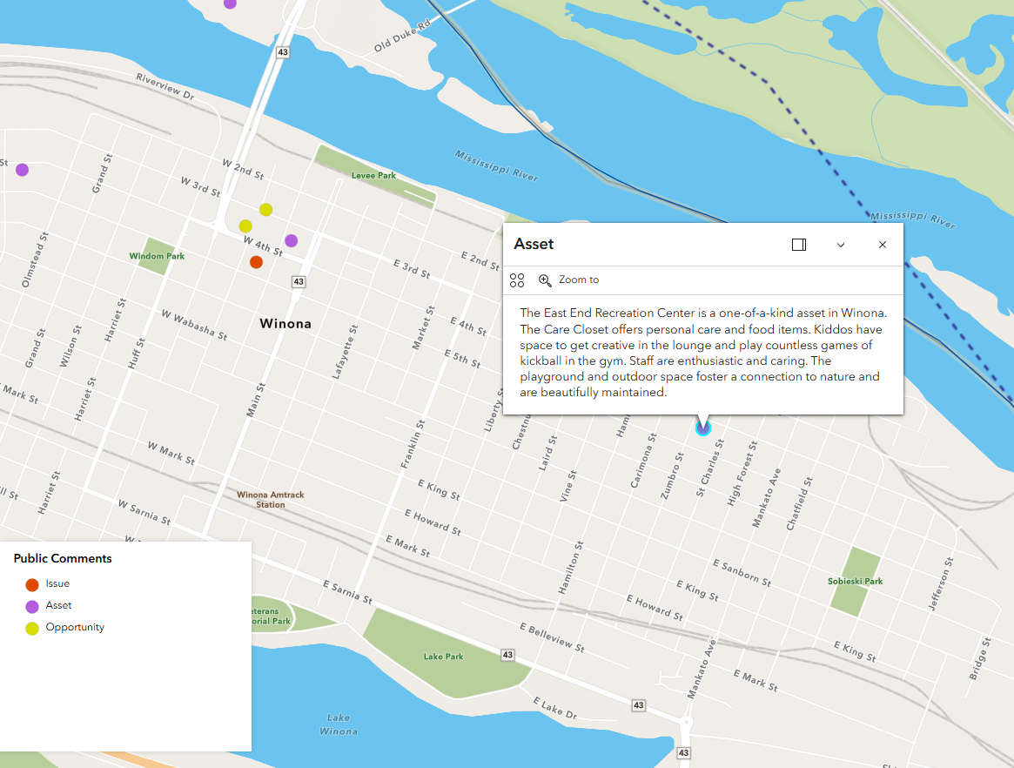

Open House
One open house will be held towards the end of the engagement process. This meeting will allow the project team to interact directly with community members to solicit feedback, share information, and educate the public about the project. Open houses meetings allow for in-depth conversations with stakeholders that can be difficult during pop-up events. Meeting materials will be made available online for community members who are unable to attend the meeting.
Building from the community survey results, the SRF team will work with the Village to develop a set of engagement and educational materials for participants to view and respond to. Materials may include items such as, but not limited to, visual preference surveys, including photographs and graphics, educational materials about existing planning documents (such as the 2050Comprehensive Plan), and mapping activities expanding on the results of the Interactive comment map.

Pop-up Events
The project team will collaborate with community event organizers to attend prescheduled community events to solicit community feedback and promote the project. Two pop-up events will be held at times that coincide with existing events in the Village of Germantown.
Engagement typically requires approximately five minutes of stakeholders’ time with the intention of meeting people where they are rather than asking them to come to a specific event. Pop-up events are an opportunity to engage with community members who do not traditionally involve themselves in the planning process and often reach a wider audience than traditional engagement events, such as open houses.
The following events have been identified for Pop-up events:
- Maifest Germantown (May 15-17, 2026)
- Fourth of July Celebrations (July 4, 2026)

Focus Groups
Two focus group meetings will be held between mid-April and mid-May to solicit feedback from groups of stakeholders that have a specific interest in the project. Stakeholder groups could include, but are not limited to, property owners, business owners and operators, and/or community organizations.
Discussions at focus group meetings will be facilitated in-person by SRF staff, with the participation of six to 12 community members. Meeting agendas and discussion topics will be shared with participants in advance of the meeting to ensure they have time to prepare. Discussion items will be catered to the interests of each specific group.

Public Participation Timeline
Implementation of the engagement plan occur beginning in May 2026 and extending though the summer with minor timeframe adjustments as needed.

Promotional Tools and Communication
The project team will utilize a wide range of communication and outreach strategies to promote engagement opportunities. Outreach opportunities will be shared at popular community locations in-person, as well as online, to reach a wider audience. Project interest groups will also help with promotion throughout the planning process. Specific outreach tools that will be used include:
- Project website
- Email updates
- Direct outreach to interest groups
- Social media posts
- Traditional media and press releases

Project Website
The project webpage will be used to share information and updates about the public engagement process and will serve as a one stop shop for all information related to the engagement process. The website will be hosted externally to the Village of Germantown website and will be maintained by SRF Staff. Participants will be referred to the website to access online resources (links to the online community survey and interactive comment map), and review relevant and timely information about the project, including engagement results, project status updates, information on virtual and in-person engagement opportunities, and meeting agendas and materials.

Direct Outreach to Interest Groups
The project team will work with Village Staff to complete direct outreach to key community groups in the Village. As a part of this effort, the project team will ask these groups to share information about engagement events with their membership:
- Germantown School District
- Germantown Senior Center
- Germantown Chamber of Commerce
- Kiwanis Club
- Germantown Community Coalition

Social Media Posts
The project team will use existing Village of Germantown social media accounts to promote the project and advertise specific engagement opportunities. Social media posts will provide a space for promoting engagement activities to a larger audience. The project team will also work with local partners to provide content for their social media outlets, to reach those who may not be following Village of Germantown social media pages.

Traditional Media and Press Releases
At the discretion of the Village, traditional media options, such as sending mailers and publishing press releases could be used to inform the public about upcoming engagement opportunities. If directed, the SRF team will develop press releases, mailers, or other traditional media materials to support these efforts.

Reporting
After completion of all engagement tasks, the consultant team will prepare a report that summarizes the results of engagement. That report will be provided to the Plan Commission for review and presented to Village Board for discussion. The final report will, at a minimum, include:
- A summary of responses from each engagement activity.
- A list of key findings.
- Recommendations intended to inform the development of site-specific land use plans, zoning regulations, and design guidelines.
- Appendices including full engagement results.

Accessibility
All public facing website content created by the engagement team will comply with Web Content Accessibility Guidelines (WCAG) 2.1 and meet any other reasonable standards for accessibility. Public facing materials (e.g. display boards, handouts, reports, summaries) will be prepared in plain language and have an accessibility check before sending materials to project team for review. Any in-person engagement activities will be hosted at locations with ADA accessible facilities. Online engagement activities and live virtual meetings will include opportunities to participate for those without broadband access, such as dial-in and /or paper options.

